clc;clear;close all;

prob1
data3 = importdata("HW3- building seismic response data.txt");
t = data3(:,1);
ground = data3(:,2);
top = data3(:,3);

Sampling Rate
sr = round(1/(t(2)-t(1)));
pt = length(t);
fc=0.08;
ft=0.1;
delta = top - ground;
delta = ormsby(delta,ft,fc,sr,pt);
delta = delta - mean(delta);
vel = cumtrapz(t,delta);
vel2 = detrend(vel);
trend = vel - vel2;
disp_2 = cumtrapz(t,vel2);
figure
plot(t,disp_2)
xlabel('Time (s)')
ylabel('Displacement (mm)')
title('Displacement: Ormsby low pass filter with fc=0.08Hz and ft=0.1')
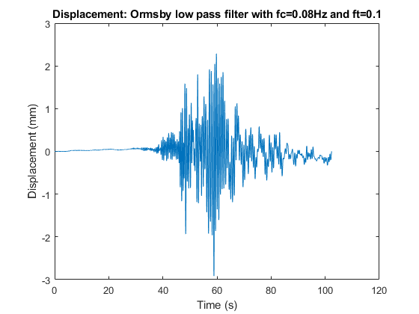

prob2

Assign data
[data2,txt,raw] = xlsread('Homework-2 data set-RCF-Four Specimen Test Data.xlsx');
t = data2(:,1);
RCF6_x = data2(:,2);
RCF6_y = data2(:,3);
RCF2_x = data2(:,4);
RCF2_y = data2(:,5);
RCF4_x = data2(:,6);
RCF4_y = data2(:,7);
RCF3_x = data2(:,8);
RCF3_y = data2(:,9);

Sampling Rate
sr = round(1/(t(2)-t(1)));
pt = length(t);

case a (relative acceleration)
(RCF2_100_A04 vs. RCF2_100_A10)
fc=0.1;
ft=0.15;
RCF2_R = RCF2_y - RCF2_x;
% low-pass ormsby filter
RCF2_FR = ormsby(RCF2_R,ft,fc,sr,pt);
RCF2_FR = RCF2_FR - mean(RCF2_FR);
vel = cumtrapz(t,RCF2_FR);
vel2 = detrend(vel);
trend = vel - vel2;
disp_2 = cumtrapz(t,vel2);
figure
plot(t,disp_2)
xlabel('Time (s)')
ylabel('Displacement (mm)')
title('Displacement: Ormsby low pass filter with fc=0.1Hz and ft=0.15')
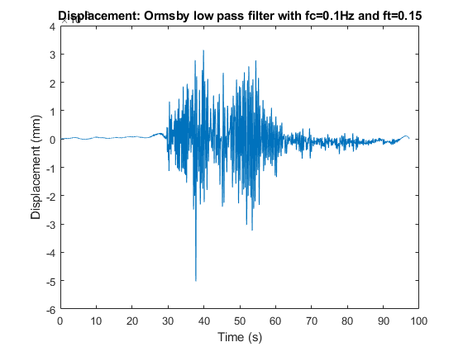

case b (relative acceleration)
(RCF4_110_A04 vs. RCF4_110_A10)
fc=0.1;
ft=0.15;
RCF4_R = RCF4_y - RCF4_x;
% low-pass ormsby filter
RCF4_FR = ormsby(RCF4_R,ft,fc,sr,pt);
RCF4_FR = RCF4_FR - mean(RCF4_FR);
vel = cumtrapz(t,RCF4_FR);
vel2 = detrend(vel);
trend = vel - vel2;
disp_2 = cumtrapz(t,vel2);
figure
plot(t,disp_2)
xlabel('Time (s)')
ylabel('Displacement (mm)')
title('Displacement: Ormsby low pass filter with fc=0.1Hz and ft=0.15')

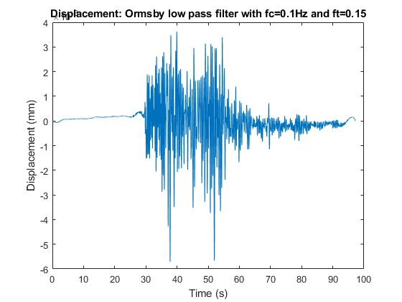

ormsby function
function y = ormsby(x,ft,fcut,sr,pt)
dt = 1/sr;
Nw = pt;
mnw = fix(Nw/2);
Nww = 1:1:Nw;
w = kaiser(Nw,10);
orm(mnw+1) = 2*(fcut+ft)/2; % at t=0 amplitude is 2fa = 2*(fc+ft)/2
t1=0;
for nn=mnw+2:Nw
t1=t1+dt;
orm(nn)=(cos(2*pi*fcut*t1)-cos(2*pi*ft*t1))/(ft-fcut)/t1^2/2/(pi)^2;
end
for ii=1:mnw
orm(ii)=orm(Nw+1-ii);
end
%window time interval
tw=w.*orm';
Xaf=conv(x,tw,'same')*dt;
y = x - Xaf;
end
Published with MATLAB® R2022a

